# SSRS Master Tutorial – AdventureWorks2014

## PART 1 – BASICS

### Example 1: Creating Your First Table Report

**Goal:** Create a report showing `Product Name, Category, List Price, and Sales` from AdventureWorks2014.

**Steps:**

1. **Open SSDT (SQL Server Data Tools)** → Create new **Report Server Project**.

2. **Add Shared Data Source**

- Right-click "Shared Data Sources" → Add New Data Source → Name: `AW2014_Source`

- Type: Microsoft SQL Server

- Connection: `Data Source=YourServer;Initial Catalog=AdventureWorks2014;Integrated Security=True`

3. **Create Dataset**

- Right-click "Shared Datasets" → Add New Dataset → Use Shared Data Source.

- Query:

```sql

SELECT p.Name AS ProductName, pc.Name AS Category, p.ListPrice, SUM(sod.LineTotal) AS TotalSales

FROM Production.Product p

JOIN Production.ProductSubcategory ps ON p.ProductSubcategoryID = ps.ProductSubcategoryID

JOIN Production.ProductCategory pc ON ps.ProductCategoryID = pc.ProductCategoryID

JOIN Sales.SalesOrderDetail sod ON p.ProductID = sod.ProductID

GROUP BY p.Name, pc.Name, p.ListPrice

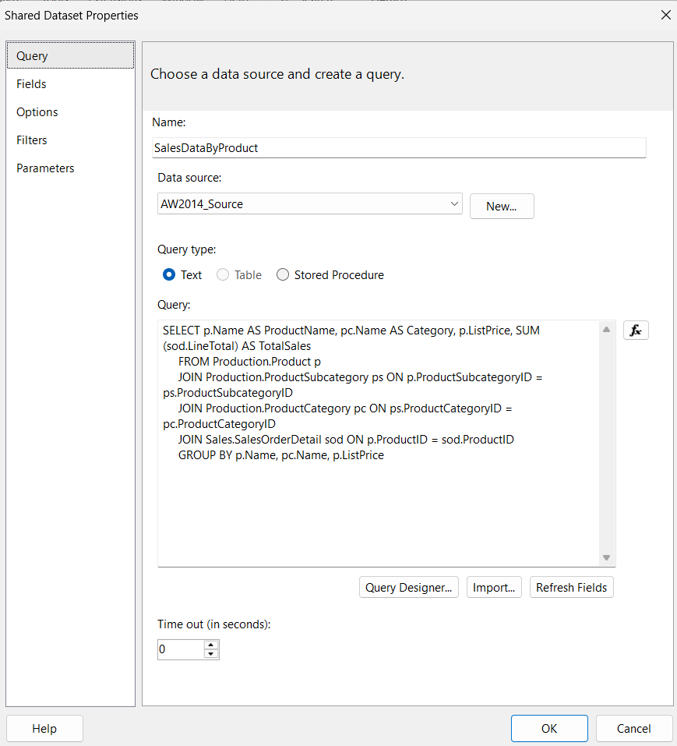

```

4. **Add New Report** → Insert **Table** → Map fields.

5. **Preview Report**.

**Step 2 – Create a Table Report**

1. **Insert Table**:
   * Right-click inside the design area → **Insert** → **Table**.
   * A blank 3-column table will appear.
2. **Add Fields to Table**:
   * Drag **ProductName** from the dataset to the first column.
   * Drag **Category** to the second column.
   * Drag **TotalSales** to the third column.
3. **Format the Table**:
   * Right-click on the header row → **Insert Row Above** → type column names: Product Name, Category, Total Sales.
   * Right-click **TotalSales cell** → **Text Box Properties** → **Number** → select Currency.
4. **Sort Data (Optional)**:
   * Right-click on table → **Tablix Properties** → **Sorting** → Sort by TotalSales descending.
5. **Preview Report**:
   * Click **Preview** → you should see a list of products with their category and sales.

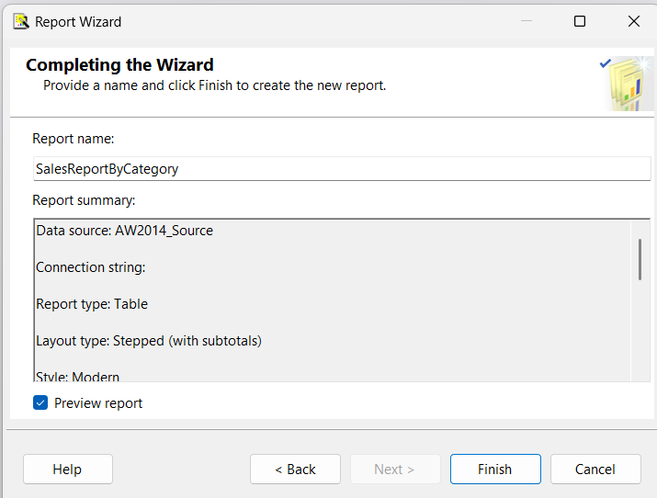

---

**Step 3 – Create a Matrix Report**

1. **Insert Matrix**:
   * Right-click on design area → **Insert** → **Matrix**.
   * A blank matrix will appear with **Row Group** and **Column Group** placeholders.
2. **Define Rows & Columns**:
   * Drag **Category** to the **Row Groups** (left cell).
   * Drag **ProductName** just below Category in Row Groups (nested grouping).
   * Drag **ListPrice** to the **Column Groups** if you want analysis by price (or skip for now).
   * Drag **TotalSales** to the **Data** area (middle cell).

* **Top-left cell** → This is **Column Groups** area.
* **Bottom-left cell (labeled Rows)** → This is the **Row Groups** area. ✅

So in your case:

1. **Category** → Drag to **bottom-left cell** (Row Groups).
2. **ProductName** → Drag just **below Category** inside Row Groups (nested).
3. **ListPrice** → If used for grouping, drag to **top-left cell** (Column Groups).
   * **TotalSales** → Drag to **bottom-right cell** (Data area).
4. **Format**:
   * Change **TotalSales** to currency format.
   * Resize columns for better readability.
5. **Add Subtotals**:
   * Right-click on the **Category row** → **Add Total** → **After** → This will sum sales for each category.
6. **Preview Report**:
   * You’ll now see a pivot-style table where **Categories** expand to show products and their sales.

## PART 2 – INTERMEDIATE

### Example 2: Adding Parameters

**Goal:** Allow filtering by Product Category.

**Steps:**

1. Modify Dataset query:

```sql

SELECT p.Name AS ProductName, pc.Name AS Category, p.ListPrice, SUM(sod.LineTotal) AS TotalSales

FROM Production.Product p

JOIN Production.ProductSubcategory ps ON p.ProductSubcategoryID = ps.ProductSubcategoryID

JOIN Production.ProductCategory pc ON ps.ProductCategoryID = pc.ProductCategoryID

JOIN Sales.SalesOrderDetail sod ON p.ProductID = sod.ProductID

WHERE pc.Name = @Category

GROUP BY p.Name, pc.Name, p.ListPrice

```

2. SSRS auto-creates parameter **@Category**.

3. Provide available values:

```sql

SELECT DISTINCT Name FROM Production.ProductCategory

```

4. Preview and select category.

---

### Example 3: Conditional Formatting

**Goal:** Highlight products with ListPrice > 1000 in **red**.

**Steps:**

1. Select `ListPrice` cell → Right-click → Text Box Properties → Font → Color → Expression:

```ssrs

=IIF(Fields!ListPrice.Value > 1000, "Red", "Black")

```

---

## PART 3 – ADVANCED

### Example 4: Drill-Down Report

**Goal:** Show Sales by Territory → Expand to see Orders.

**Steps:**

1. Create parent group on `Territory`.

2. Add detail rows for orders.

3. Group Properties → Visibility → Hide initially, toggle by Territory field.

---

### Example 5: Drill-Through Report

**Goal:** From Territory report, click a Territory name → Open Order Details report.

**Steps:**

1. Create second report (OrderDetails).

2. Add parameter **@TerritoryID**.

3. Modify query to filter by parameter.

4. In main report, right-click `Territory Name` → Text Box Properties → Action → Go to report → Select OrderDetails → Pass TerritoryID.

---

### Example 6: Subreport

**Goal:** Include product inventory report inside main sales report.

**Steps:**

1. Create inventory report separately.

2. In main report, Insert → Subreport → Point to inventory report.

3. Pass `ProductID` as parameter.

---

### Example 7: Charts

**Goal:** Show Monthly Sales Trend.

**Steps:**

1. New dataset:

```sql

SELECT YEAR(OrderDate) AS Year, MONTH(OrderDate) AS Month, SUM(TotalDue) AS TotalSales

FROM Sales.SalesOrderHeader

GROUP BY YEAR(OrderDate), MONTH(OrderDate)

ORDER BY Year, Month

```

2. Insert Chart → Column Chart → Assign fields.

---

### Example 8: Maps

Use built-in **Map Wizard** and link sales by territory.

---

## PART 4 – NAVIGATION

### Example 9: Linking Reports

Use **Drill-Through Actions** or **Jump to URL** to navigate between reports.

---

## PART 5 – DEPLOYMENT

**Steps:**

1. Right-click project → Properties:

- TargetServerURL = `http://YourServer/ReportServer`

2. Build & Deploy.

3. Open **Report Manager Web Portal**:

- URL: `http://YourServer/Reports`

4. Manage permissions and create folders.

---

## PART 6 – SUMMARY

- Learned SSRS from basics to advanced.

- Used AdventureWorks2014 for real data.

- Built multiple report types: table, parameterized, conditional formatting, drill-down, drill-through, subreports, charts, and maps.

- Implemented navigation between reports.

- Published reports to SSRS Web Portal.

---